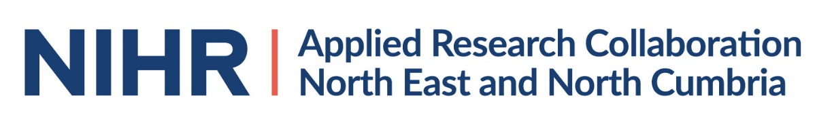
APPLICATION FORM FOR A FUNDED MASTERS DEGREE

Name (Title, forename, surname)

Please confirm you have a Batchelor level degree (or will have completed one by the course start date)

Yes/No

Title of your degree

Grade achieved (or if still studying, predicted to achieve)
(Please note a grade of 2:1 or above is essential. If you are submitting a predicted grade please supply a supporting letter or email confirming your predicted grade from your course lead or supervisor)

Which University do you wish to study at? (select one)

Northumbria
Newcastle

Which Masters’ degree are you interested in studying?

Please confirm that you meet the entry requirements for this course? (essential)

Yes/No

Are you currently employed?

Yes/No

If yes please confirm that your workplace will release you for the
time of study (essential – delete as appropriate)

Confirmed/Not confirmed / Not applicable

What is the research component of this Masters degree? (publicly available information from the University website is sufficient)

Which ARC theme will you link with? Please select one

Multi-morbidity, Ageing and Frailty
Supporting Children and Families
Prevention, Early Intervention and Behaviour Change
Integrating Physical, Mental health and Social care
Inequalities and Marginalised Communities
Knowledge Mobilisation and Implementation Science
Enabling Methodologies (including data science)

Please outline why you have chosen this theme (100 words)

How will this degree help you to progress your Applied Research career? (200 words)

Please briefly explain how you think this degree could help the ARC NENC achieve its vision of ‘better, fairer health and care at all ages and in all places’ (200 words)

Please save this form and send it by email as an attachment, with your CV, to ARCNENC@cntw.nhs.uk by 12 noon on Monday 31 August 2021.

